APPENDIX A
PHOTOGRAPHS TAKEN DURING JIV AT 18” TEBIDABA-BRASS PIPELINE AT OYEREGBENE COMMUNITY, SOUTHERN IJAW L.G.A, BAYELSA STATE ON 2O^{TH} JUNE, 2024.
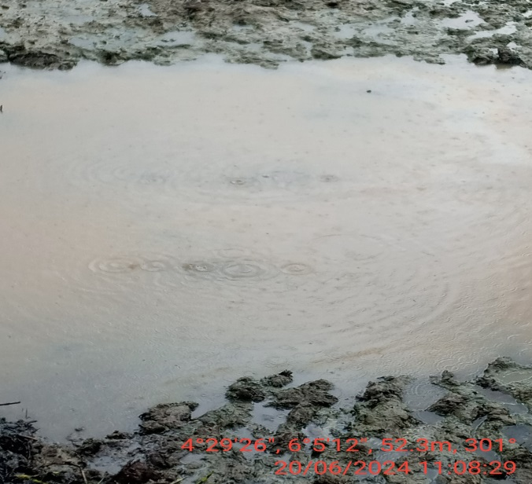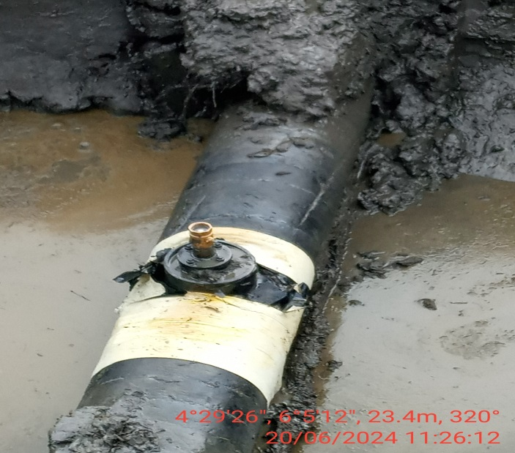
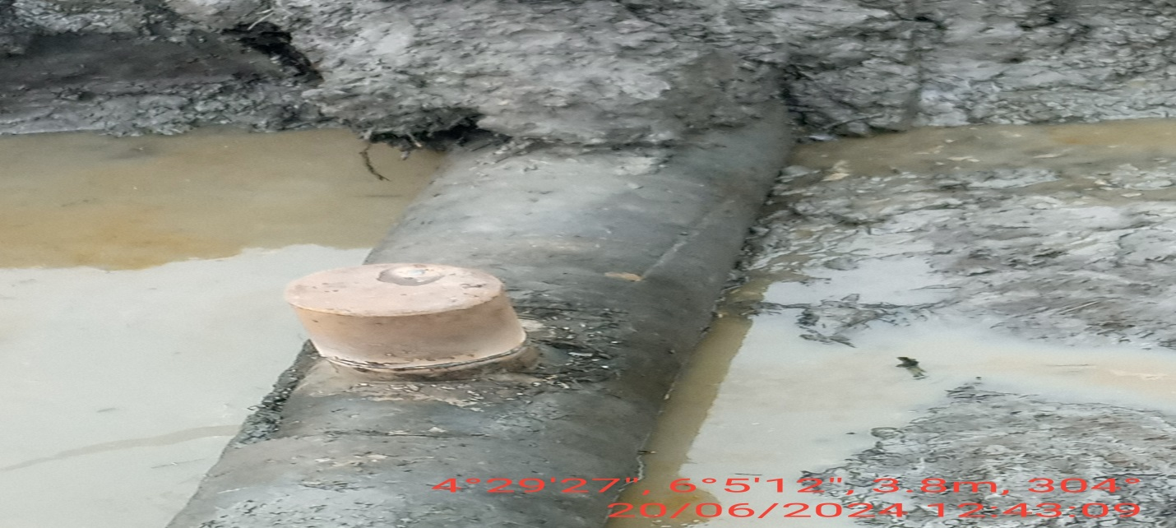
FIG.1: (L-R) THE INCIDENT POINT BEFORE EXCAVATION.
FIG.2: 2” VALVE INSTALLED AT 12 O’ CLOCK POSITION OF THE PIPELINE FOR POSSIBLE CRUDE OIL THEFT ACTIVITY BY VANDALS.
FIG.3: THE INDIDENT POINT AFTER REPAIRS.

